A New Bionic Ankle Based on Adams and MATLAB

Abstract
简要的说明本文的背景、研究内容及成果（论文大体完成后写这块内容）

关键词：4-5个关键词

Content
A New Bionic Ankle Based on Adams and Matlab I
Abstract I
Content II
1 Introduction 3
1.1 Background and Significance 3
1.2 Predecessors 3
2 Theoretical Design 3
3 Structural Design 3
4 Hardware Design 3
5 Software Programming 4
6 Experiment 4
7 Conclusion 4
参考文献 4
附录 5

Introduction

Background and Significance
Nowadays, the need of artificial leg has grown as more people get injured in severe accidents. On the other hand, to create human robots, they also need to have a bionic ankle to provide more freedom in moving the foot. A new version of a leg must be created. In the system of the leg, the ankle is the utmost important factor. It maintains balance of the human body, absorbs shock from the walking, running, and jumping, and allows a wide range of movement.
Over time, artificial legs have improved in design, but have been incapable of actively adapting to different walking posture in similarly to a biological counterpart. The ankle decides the ability to adapt to different postures. It decides the leeway for a disabled human to move their foot. However, most artificial leg does not have a joint that aids people to walk, and grab hold of the ground. My goal in creating the bionic ankle is to simulate those of a real human ankle and have a joint to aid in maintaining balance and allowing more freedom in movement.

Predecessors
One predecessor of the bionic leg is Hugh Herr’s bionic leg. Hugh Herr’s bionic leg ankle design focuses on the dorsiflexion and plantar flexion of the leg, and only focus on the assistance of walking gait.
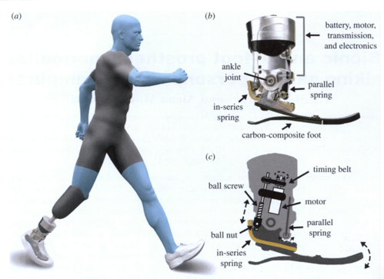
Hugh Herr’s design fails to allow the pronation and supination movement of the ankle, and also decreasing the stability and balance of the leg.

Theoretical Design
s
Mechanical Bionic Ankle | Human Ankle | Function
Spring System | Articular Cartilage, ligaments | Absorb shock
Printed Leg | Fibula, Tibia | Support the body
Universal Joint (Block) | Talus | Provides surface to the two joints
Universal Joint (upper Yolk) | Upper joint | Allows dorsiflexion and plantar flexion
Universal Joint (lower Yolk) | Lower joint | Allows pronation and supination
Drive system | fibularis longus, tibialis anterior | Controls the movement of the ankle
3D-printed foot | Foot | Supports the body

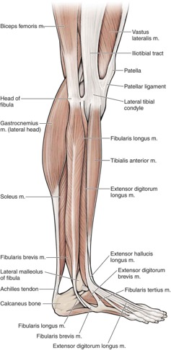
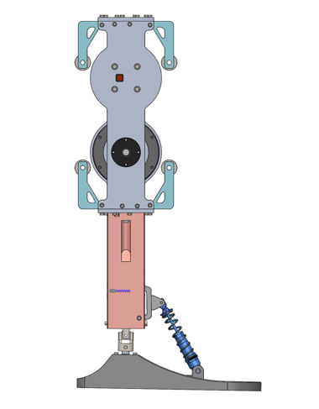

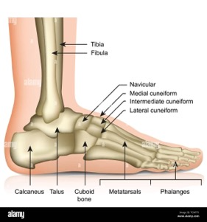

- Spring system:
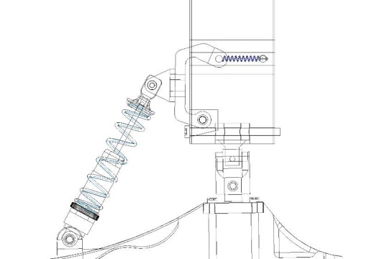
The spring system acts as a shock absorber to the system, similarly the articular cartilage in the human ankle. It provides support to the foot, similarly to ligaments.

- 3D printed legs:
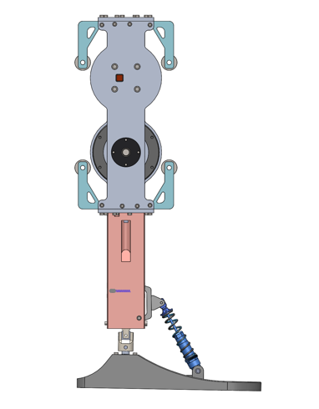
The 3D printed legs provide support to the drive system of the leg, which acts like the bones of a human body, which also provide attachment to the muscles. In my human ankle model, the 3D printed legs correlate to the bones Fibula and Tibia. Different from the human body, the 3D printed legs cannot rotate. It is an immovable object. This is due to my focus on simulating the ankle. Also, the lower leg length of the bionic ankle is similar to the real human leg, which is around 500 mm.

- Universal Joint:
The universal joint is a mechanical component that allows two-dimensional movement, similarly to the ankle’s movement. It contains three parts: upper Yolk, block, and lower Yolk. The upper Yolk and the lower Yolk allows different directions of movement. This corresponds to the ankles joint, which contains an upper ankle joint and a lower ankle joint. The upper ankle joint, formed by the Fibula, Tibia, and surface of Talus, controls the dorsiflexion and the plantar flexion. The lower ankle joint, formed by the talus and the bones of the foot, controls the pronation and supination movement. The universal joint is like the Talus, forming the two joints that allow the leg to move.
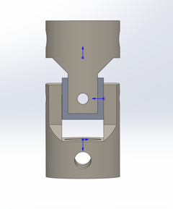

- Drive system:
The drive system consists of two motors, where they simultaneously control the dorsiflexion-plantar flexion action, and the pronation-supination action. The drive system acts like fibularis longus and tibialis anterior, which also simultaneously controls these directions.

Angle of the foot:

After experimenting with the maximum angle of the leg, I listed the data in the following table:
Motion | Maximum angle(°)
Dorsiflexion | 27.6
Plantar flexion | 31.6
Pronation | 24.0
Supination | 11.0

Structural Design

Introduction
The whole ankle consists of three parts: the upper leg, the lower leg, and the foot. The upper leg is where the two motors and guide wheels is going to be. The lower leg is where the springs, the mechanism to absorb the shock. The foot is the movable part of the whole ankle.

Upper Leg
An average human calf is around 500mm. So, for the upper leg, I estimated it to be a length of 250mm, around one half of the whole leg. The upper leg is where I need to put the two motors.
I first need to design two boards that can fix the motors. The motor has a diameter of 89mm. I estimated that I need 10 mm of spacing between the motors for it to not crush into each other. Also, to avoid interference between the two motors, I put one motor on the side of sideboard, and the other motor on the side of another sideboard, with them at two different levels. This means I need the same distance from the side of the board to each motor’s center. After calculation, the motor’s center is decided to be 65.5 mm away from the top and bottom side of the board. To protect the motor, I also designed a circular baffle on the sideboard to cover the motor. This circular baffle has a diameter of 95mm, which covers the motor’s 89 mm diameter. Additionally, a small hole must be at present for the motor’s external DIP switch, which is used to control the ID of the motor. Moreover, on the other end of the sideboard, there must be a hole for the axle, which is set for 10mm.
The top boards and bottom boards of the upper leg are different. Both boards need to have a support for the guide wheels, an L-shaped structure with a hole to put in the guide wheels. The bottom board also need to connect with the bottom leg, making the placing of screws much harder.
The guide wheels are attached to the top and bottom boards through the supports. They are used to guide the steel wire rope, which ultimately will move the leg.

Lower Leg
The lower leg mainly consists of a 3D-printed block, which connects the foot and the upper leg. One notable feature is the four slanted holes on its four sides, which is used to screw in the screws.
The lower part of the lower leg is where the tension springs are placed. There are two springs connected with a tension spring, used to absorb the shock from the leg. To attach the two springs and the tension springs together, there are two connectors for it. Each connector consists of a triangular connector to connect the spring, then a 3D printed connector for the tension spring. The two connector parts are fastened by screws, for which in static position, the screw head touches the 3D printed lower leg juts right.
In addition to the spring, a gimbal joints is needed to actually connect the foot with the lower leg. A hole is dug on the bottom of the lower leg for this gimbal joint.

Foot
The foot is connected to the gimbal joint mentioned in the lower leg part. It is attached a structure, specially designed to withstand immense forces (as it breaks in the first version of the ankle). The structure is then attached to the actual foot, which have these features:
- It has two structures on the top of the foot to connect the springs.
- There are four holes that for the steel wire ropes.
- The bottom of the foot craved for a gyroscope.
- The whole structure mimics a human foot

Conclusion
The final design of the ankle looks like this:
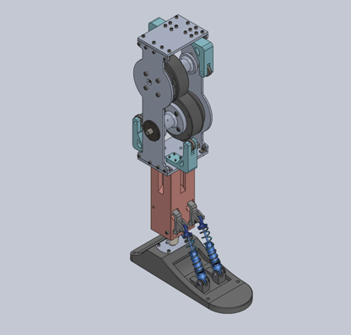

Hardware Design

Introduction
For the hardware of the ankle, I used motor MS9015, 24V battery, TTL,-RS485, esp32, gyroscope JY62.

Motor MS9015
The motor MS9015 has the following statistics:
- a rated torque of 1.55 N m
- a rated voltage of 24 V
- a rated speed of 100 rpm
- a max power of 17 W

The torque and power of MS9015 is strong enough to give enough force to move the wheel. A smaller one cannot easily move the foot. A larger one makes the whole ankle too heavy.
It uses RS485 protocol.

24V battery
A 24V battery can provide enough voltage to use the motor.

TTL – RS485
The motor uses RS485 protocol. I sued Arduino to control the motor, so a TTL – RS485 translator is needed to communicate with the motor.

Esp32
The purpose of esp32 is for its wireless connection to other esp32. For the gyroscope, I intended to attach to the bottom of the foot, which means that it will need wireless connection.

JY62
JY62 is a gyroscope that can provide the pitch, roll, and yaw of the foot through fusion algorithm. The stable output of the gyroscope can be used to do PID controller.

Software Programming
这一块重点说说自己这个装置的特点，能实现什么样的功能，（贴图说明）
比如变形式机器人，可以说明每个变形形态的特点，以及为什么设计这个变形形态。
多模式机器人：可以说明每个模式的特点，设计该模式的意义等，
多功能机器人：可以重点说明每个功能的运行状态，以及该功能的优点及必要性。

Experiment
可以先自己设计实验，再根据实验室的实际情况，来做实验，
设计实验的原则：可以设计定量实验，来探究机器人的某些性能极限，
也可以设计对比实验，（控制变量法）

Conclusion
说说本项目的完成情况，因为我们最终做出的成品和最初的设计肯定是有出入的，说明制作完成的成品有哪些优点，有哪些需要改进的地方，
在未来的研究中，可以对该项目做如何的改进和优化等。

参考文献
- 尚辉, 张飞霆, 邵旭东, 孟翔, 李同玉. 中国航天实现首次海上发射-揭秘CZ-11海射型运载火箭及其发射服务应用[J]. 国际太空, 2019(06): 4~9.

附录

https://www.kenhub.com/en/library/anatomy/the-ankle-joint

